2019-2020 EĞİTİM-ÖĞRETİM YILI
Exam mark :
Name & Surname :
Number :
ERDEMLİ AKDENİZ ANADOLU LİSESİ
İNGİLİZCE DERSİ 2. DÖNEM 1. YAZILI SORULARI

A- Put the verbs into the correct tense (simple past or past progressive) (20 puan)
1) While I (do)________ the washing-up, I (break)______ a plate.
2) While Tom (study)_______ the English exam, his mother (watch)_________ Tv series.
3) I (have)_________ dinner when I suddenly (hear)_________ a loud bang.
4) The doorbell (ring)_____________ while I (have)_____________a bath.
5) She went to school, (take)__________ out her textbook and (begin)_________ to memorize.

B- Put the verbs into the correct tense (Conditionals ; Type 1) (12 puan)
1. If you __________ (talk) to the parrot, it __________ (repeat) what you say.
2. I __________ (take) my jacket with me if it __________ (be) cold tomorrow.
3. If Peter __________ (not feed) the cat, it __________ (die)

C- Make zero conditional sentences using the information below. (8 puan)
(Conditionals ; Type 0)
1. you / mix / blue and yellow / you / get / green
If you mix blue and yellow, you get green.
2. you / heat / ice / it / melt
___________________________________
3. you / lose / weight / you / not eat
___________________________________
D- Choose the correct form (enough & too) (20 puan)
- She can’t sleep because she has drunk enough/too much coffee!
- I haven't got enough/too much money to pay the bill.
- This room isn’t big enough/too big for us. We will get the bigger one.
- I put the coat on because it was cold enough/too cold!
- The shoes were small enough/too big so I didn't buy them
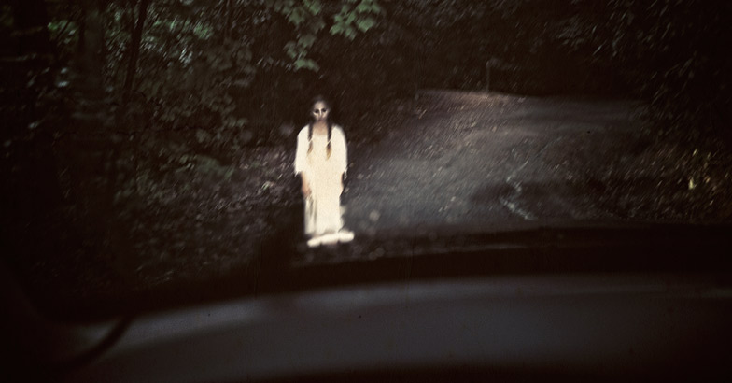

A TRUE GHOST STORY

It was midnight on October 31st last year.
Susan Lee was driving home after visiting her sister.
The road was clear and she was driving carefully.
Suddenly, a young girl stepped out in front of her. She was wearing a white dress and looking at her meaninglessly.Susan stepped hard on the brake pedal but it was too late. She got out of the car but there was nobody there. While she was looking under the car, she felt a cold wind on her face and felt strange. She was still looking under her car when a truck stopped behind her. The truck driver, a middle-aged man, walked up to her and asked her if she needed help . So, she told him what had happened. He didn’t seem surprised. 'In October 1978, there was a car accident on this road and a hitchhiker died.
‘‘You're not the first to have seen his ghost here’’, he said in a mysterious tone.

E- Answer the questions according to the passage above. (20 puan)
1- When did Susan see the ghost?

2- How was she driving her car?

3- What did Susan do when she saw the ghost?

4- Was the truck driver surprised when he heard what happened?

5- What happened on this road in 1978?

F - Choose the correct form (Possessive Adjective or Possessive Pronoun) (20 puan)
- Don’t take this chair, it’s not my/mine!
- Her/hers friends are very nice.
- Your/yours mother is taller than our/ours.
- We all love our/ours parents, they’re/theirs the best in the world.
- The cat is sleeping in it/its bed, and its/it’s kitties are playing.

