…………………PRIMARY SCHOOL
Name:
Number:
Class:

………………. ACADEMIC YEAR
4th GRADES 1st TERM 2nd ENGLISH EXAM

A.Resimlerin altına uygun eylemleri yazınız. (4x6=24)
 | playing table tennis - drawing - dancing - playing chess - reading comics - flying a kite
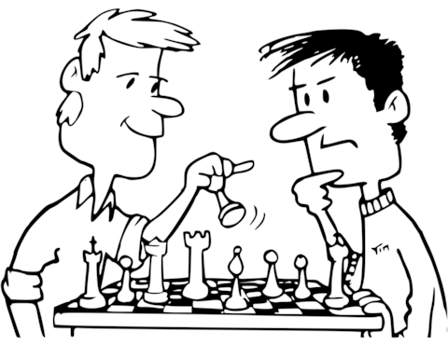 |  | 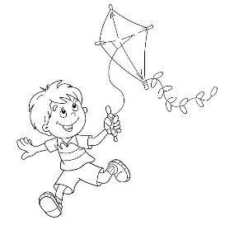 | 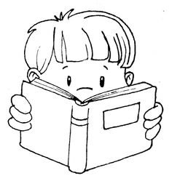 | 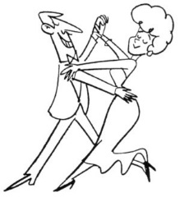 | 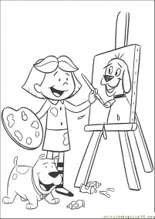 | 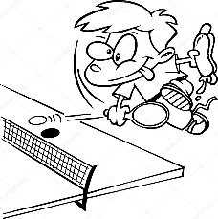
B. Boşlukları tabloya uygun olarak like veya dislike ile tamamlayınız. (3x5=15)
Coloring books | Learning English | Playing with marbles | Swimming | Watching cartoons
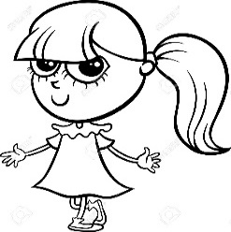

I __________ coloring books. I __________ learning English.
I __________ playing with marbles. I __________ swimming.
I __________ watching cartoons.
D. Resimlerin altına uygun cümleleri yazınız. (3X9=18)
I have lunch. I do my homework. I go to bed. I read a book. I have breakfast. I go to school. I wake up.
I go home. I have dinner.
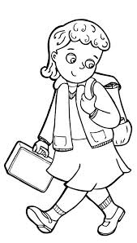
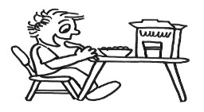
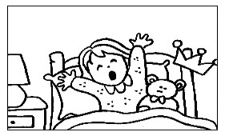
IN THE MORNING

………………………………..
………………………………… ………………………………….. ………………………………
IN THE AFTERNOON
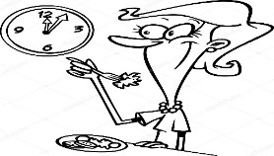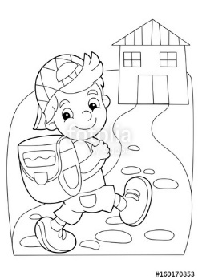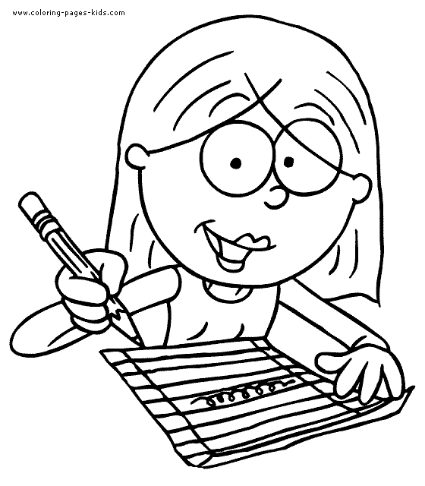
……………………………… ………………………………… …………………………………
IN THE EVENING
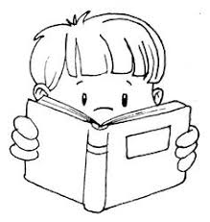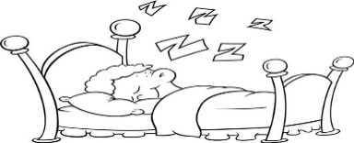
……………………………… …………………………………….. …………………………………
E.Doğru seçeneği işaretleyiniz. (2x6=12)
? a)Saturday b)Monday
Tuesday
? a)Wednesday b)Friday
Thursday
? a)Friday b)Monday
Saturday
? a)Wednesday b)Sunday
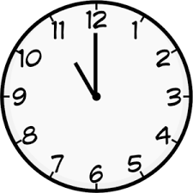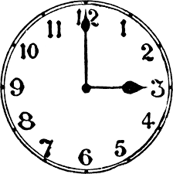
It’s ………. o’clock. It’s ………. o’clock.
a)eleven b)twelve a)four b)three
F) Choose the correct answer. (Doğru cevabı seçiniz.) (3x10=30 points)
1) 1. Is she from Italian?
No No, she isn’t. She is …………………….. 2) This is …………. ball.
A) his
Britain

A) French B) her
B) Russian C) my
C) German D) your
D) British
28
3) 3) A) scissors 4) A) thirty – five
B) ruler B) twenty - eight
C) pencil C) forty – eight
D) eraser D) twenty - three
5) A) Be quiet. 6) Friday - ……… - Sunday
B) Open the door.
C) Turn off the lights. A) Monday B) Wednesday
D) Clean the board. C) Thursday D) Saturday
7) İzmir is in the …………. 8) “Do you like playing computer games?”
A) east B) north sorusuna doğru cevap hangisi olabilir?
C) west D) south A) Yes, I do. B) Yes, I can.
10 9.I like ……………… 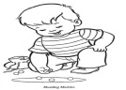 C) No, I can’t. D) No, I do
A)watching cartoons B) singing 10) “What time is it?” 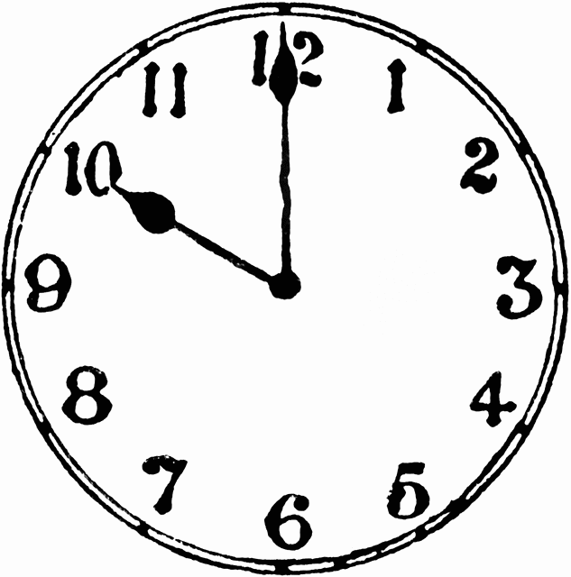
C) playing basketball D) playing with marbles A) It is o’clock
B) It is ten o’clock
CEVAP ANAHTARI C) It is o’clock ten
D) It is two o’clock.

